10.3.6 Render - Cycles Render Engine - Camera
Camera 1
Perspective 1
Orthographic 1
Panoramic 1
Equirectangular 2
Fisheye 2
Depth of Field 2
Clipping 3

Camera

Perspective
Lens Size and Angle
Control the field of view angle.
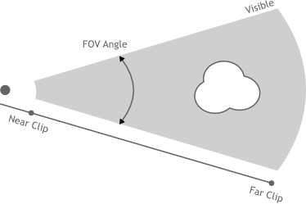

Orthographic
Scale
Controls the size of objects projected on the image.
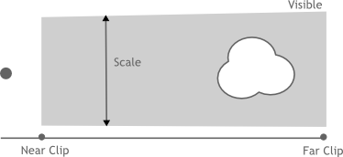

Panoramic
Cycles supports Equirectangular and Fisheye panoramic cameras. Note that these can’t be displayed with OpenGL rendering in the view-port; they will only work for rendering.

Equirectangular
Render a panoramic view of the scenes from the camera location and use an equirectangular projection, always rendering the full 360- over the X-axis and 180- over the Y-axis.
This projection is compatible with the environment texture as used for world shaders, so it can be used to render an environment map. To match the default mapping, set the camera object rotation to (90, 0, -90) or pointing along the positive X-axis. This corresponds to looking at the center of the image using the default environment texture mapping.

Fisheye
Fisheye lenses are typically wide angle lenses with strong distortion, useful for creating panoramic images for e.g. dome projection, or as an artistic effect. The Fisheye Equisolid lens will best match real cameras. It provides a lens focal length and field of view angle, and will also take the sensor dimensions into account.
The Fisheye Equidistant lens does not correspond to any real lens model; it will give a circular fish-eye that doesn’t take any sensor information into account but rather uses the whole sensor. This is a good lens for full dome projection.
Lens
Lens focal length in millimeter.
Field of View
Field of view angle, going to 360 and more to capture the whole environment.

Depth of Field
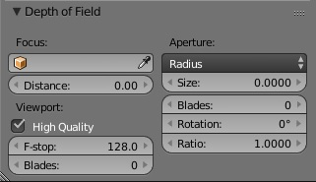
Focus
Set an object to be used as a focal point by the camera, causing the camera to focus on the selected object.
Distance
When an object is not used, the camera can be set to focus on an area in 3D space set by the distance from the camera. Using the Limit Display option, you are able to view the distance in the 3D space.
High Quality
Enables the High Quality view-port depth of field, giving a more accurate representation of depth of field. This allows the view-port depth of field to be closely represented to that of the render and render preview depth of field.
F-Stop
Viewport depth of field aperture measured in F-Stops. Smaller numbers will cause more blur in the view-port, OpenGL renders, and sequencer.
Blades
The number of polygonal sides to give blurred objects in the view-port. The minimum number of blades needed to enable the bokeh effect is 3 (triangle). Only available with High Quality
Aperture
Use F-Stop or Radius to set the aperture for the render, and render preview. F-Stop is the focal ratio, where Radius is the the raidus of the focal point.
Size/Number
Aperture radius size, or F-Stop number used for the render, and render preview. Using the F-Stop with a low number, or Radius with a large size will result in a strong blur, also allowing the use of the bokeh effect.
Blades
Total number of polygonal blades used to alter the shape of the blurred objects in the render, and render preview. As with the view-port, the minimum amount of blades to enable the bokeh effect is 3, resulting in a triangle shaped blur.
Rotation
Rotate the polygonal blades along the facing axis, and will rotate in a clockwise, and counter-clockwise fashion.
Ratio
Change the amount of distortion to simulate the anamorphic bokeh effect. A setting of 1.0 shows no distortion, where a number below 1.0 will cause a horizontal distortion, and a higher number will cause a vertical distortion.
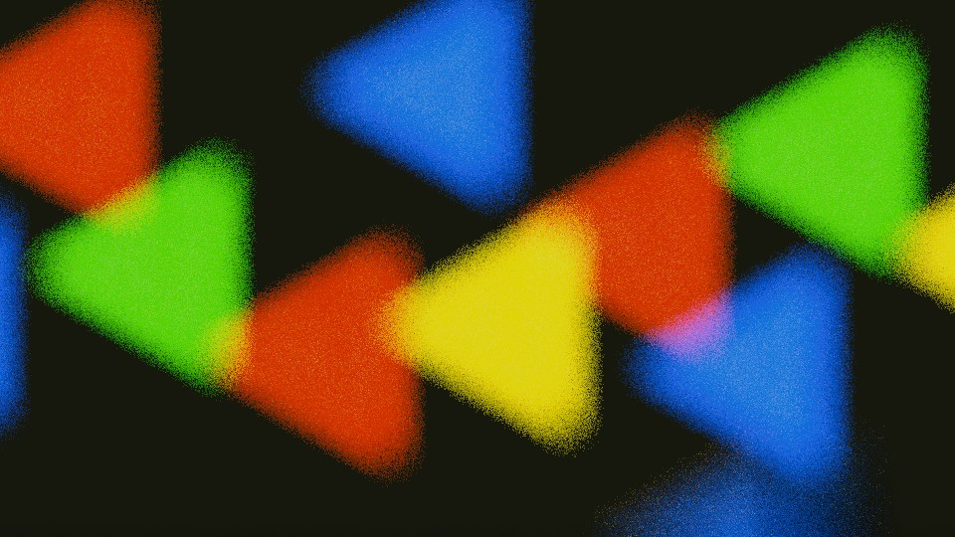

Clipping
Clip Start and End
The interval in which objects are directly visible, Any objects outside this range still influence the image indirectly, as further light bounces are not clipped.
See also
Camera Clipping.

